Tibetan refugees ready to start over in Ottawa

By MARIE-DANIELLE SMITH, Ottawa Citizen December 2, 2013

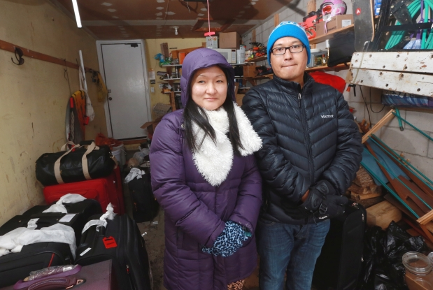

Tsechu Lamo, left, and Tenzin Tsangyang are excited by the opportunity they have in Canada.

Photograph by: Bruno Schlumberger , Ottawa Citizen
OTTAWA — When Tenzin Tsangyang stepped off the plane in Ottawa on Friday, he says the welcome was so warm he didn’t even feel the cold outside.
He is one of 10 stateless Tibetan refugees who travelled here from a settlement in Arunachal Pradesh, a state at the northeast tip of India. Seven others arrived in Toronto the same day.
Tsangyang’s parents, both Tibetan, became refugees in 1959. He was born and raised in the settlement. He says he’s grateful for the opportunity to live in Ottawa. “I’m really happy,” he says. “My status will move from stateless to a Canadian citizen.”
The goal is to have 90 Tibetan refugees resettle in Ottawa and 1,000 (about an eighth of the Tibetan refugee population in Arunachal Pradesh) across Canada in the next five years.
The new arrivals stayed together in a full house in Nepean this weekend. On Sunday, they started to move in with volunteer host families. Tuesday, they will start a settlement program with the Catholic Centre for Immigrants.
They’ll also start to look for work. Tsangyang is a software engineer who worked for IBM and other multinational companies in India. He says he hopes to use those skills here.
Tsechu Lhamo, another of the refugees, spent three years in hotel management and hopes to continue here.
“We are all very determined to work very hard and stand on our own feet,” she says, adding that this first group’s progress will have an impact on those who follow them to Canada.
Cornelius von Baeyer, head of the Ottawa branch of Project Tibet Society, the volunteer organization that is co-ordinating resettlement, says there’s a long way to go.
“It’s a gazillion miles away for us right now, even though the first are here. They’re really happy and we’re really happy, but we’ve got a long, hard road ahead of us,” he says.
The Canadian government is providing visas to the Tibetans in a decision that came in 2010 after exiled Tibetan spiritual leader the Dalai Lama urged Canada to consider resettling refugees in 2007. The move has been criticized by China, which claims Tibet as one of its territories.
There is no government funding for the resettlement project, and costs are being covered by community fundraising.
Nima Dorjee, the national co-ordinator of the project, says he quit his engineering job to manage the project full-time as a volunteer.
Dorjee says the first few days are emotional. “We’ve finally given them, for the first time in their lives, the first step to citizenship,” he says. “As Canadians we don’t even think about that.”
Among the 10 refugees is a father whose wife and children will join him in April. His will be one of the first families to settle here. Most of the others who arrived Friday are single.
Lhamo says it will be difficult to adjust to a new place, especially because each of the refugees have left many family members behind. Still, she says their reception here has been outstanding.
“Our family is far from us, but we still have a lot of Tibetans over here who are supporting us and accommodating us,” she says.
The goal, says von Baeyer, is to create communities. He says he’s part of a vibrant local group of both Canadians and Tibetans who are committed to helping stateless Tibetans find a new start.
Another member of that group is Samphe Lhalungpa, who first came to Ottawa in 1974.
Now retired, Lhalungpa organizes fundraisers for the project. He says this first group has nearly doubled the city’s Tibetan population.
“It’s not every day that this kind of thing happens. … It adds to the cultural mosaic of this country,” he says. “It’s a plus for them and hopefully we can see it as a plus for Canada.”
Another 23 refugees will join their counterparts in Ottawa over the next three months, says Dorjee. In the next six months, 200 will be resettled across Canada, in Ottawa, Toronto, Calgary, Vancouver, Victoria and the Sunshine Coast in B.C.
© Copyright (c) The Ottawa Citizen

